Program No 1: Write a program to demonstrate the FIND-S algorithm for finding the most specific hypothesis based on a given set of training data samples. Use an appropriate training dataset to implement the same.
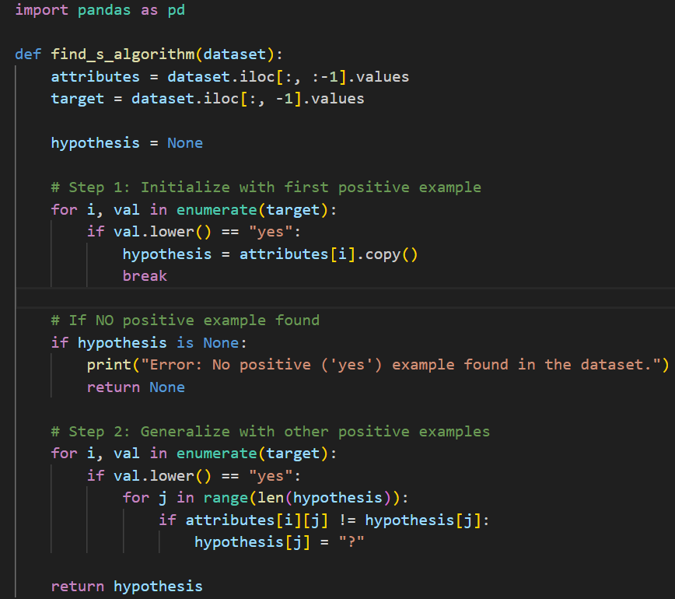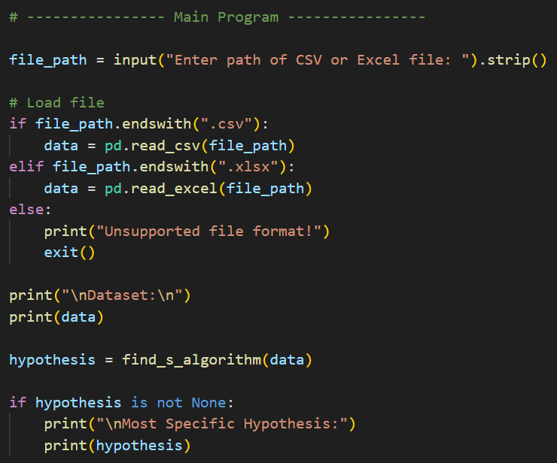

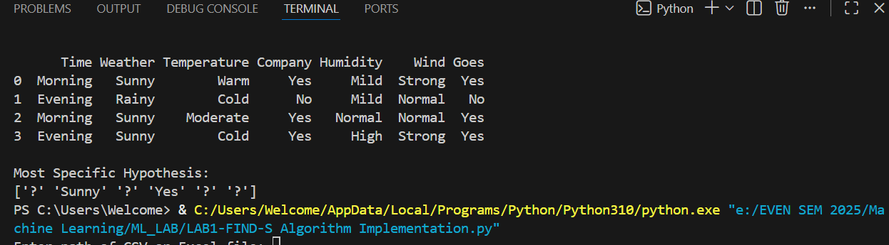
Data SET:

Time | Weather | Temperature | Company | Humidity | Wind | Goes
Morning | Sunny | Warm | Yes | Mild | Strong | Yes
Evening | Rainy | Cold | No | Mild | Normal | No
Morning | Sunny | Moderate | Yes | Normal | Normal | Yes
Evening | Sunny | Cold | Yes | High | Strong | Yes

Program No 2: Write a program to implement k-Nearest Neighbour algorithm to classify the iris data set. Print both correct and wrong predictions.

Data set:
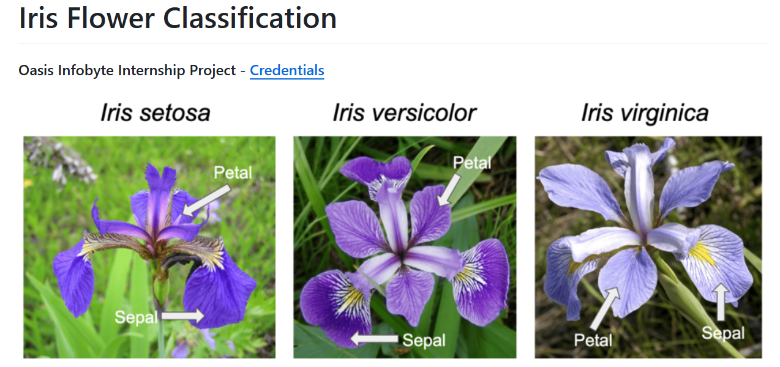
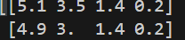It represents the input values:
- sepal length
- sepal width
- petal length
- petal width
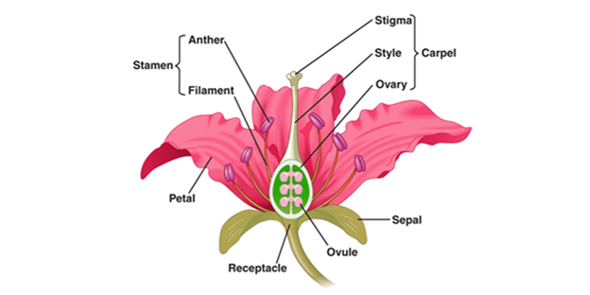
- iris_dataset["data"] → X (features)
These are the input values:
- sepal length
- sepal width
- petal length
- petal width
Shape: (150, 4) → 150 samples, 4 features

- iris_dataset["target"] → y (labels)
These are class labels:
- 0 → setosa
- 1 → versicolor
- 2 → virginica
Shape: (150,)

- test_size = 1/10
This means:
test_size = 0.1 (10% data → testing)
train_size = 0.9 (90% data → training)
So from 150 samples:
- 135 samples → Training
- 15 samples → Testing

- the algorithm looks at the 7 nearest data points
(from the training data)
and the majority class among those 7 neighbors is assigned as the prediction.

ERROR:
Go to command line pip install scikit-learn
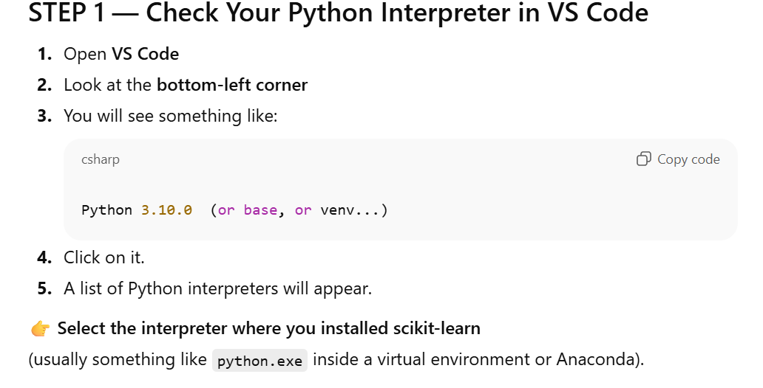

So the model correctly predicted:
- Some Setosa flowers (0)
- Some Versicolor flowers (1)
- Some Virginica flowers (2)

Why KNN
The Iris dataset is very small (150 samples)
KNN is a lazy learner — it stores all the data and makes predictions at query time.
For small datasets:
- Fast
- Simple
- No heavy computation
So KNN becomes a perfect match.

Iris dataset has only 4 numeric features
KNN works best when:
- Features are numerical
- No missing values
- Features have similar scales
Iris dataset:
- Sepal length
- Sepal width
- Petal length
- Petal width
→ All clean numeric values
→ Perfect for distance-based algorithms like KNN.
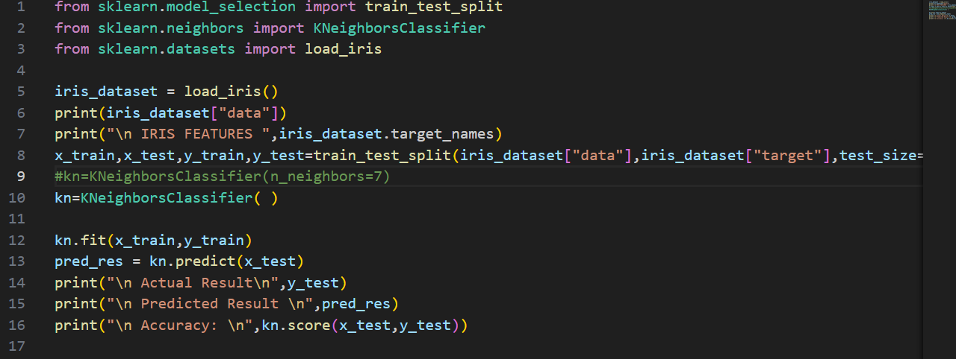

DATA SET: Imports inbuilt dataset

Program No 3: Write a program to implement the naïve Bayesian classifier for a sample training data set. Compute the accuracy of the classifier, considering few test data sets.
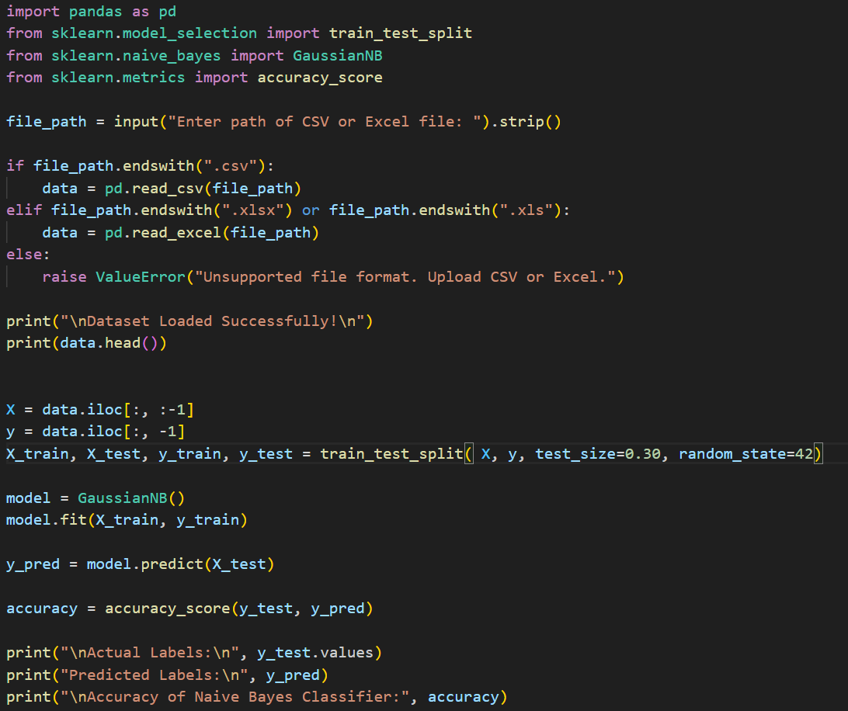
Output:

Note: The Data set to be numerical.(Gender.csv)
height | weight | Age | Gender
170 | 70 | 25 | M
160 | 55 | 30 | M
165 | 65 | 28 | M
175 | 75 | 32 | M
155 | 50 | 27 | F

Program No 4: Write a program to classify a set of documents using the naïve Bayesian Classifier model. Calculate the accuracy, precision, and recall for the appropriate data set.
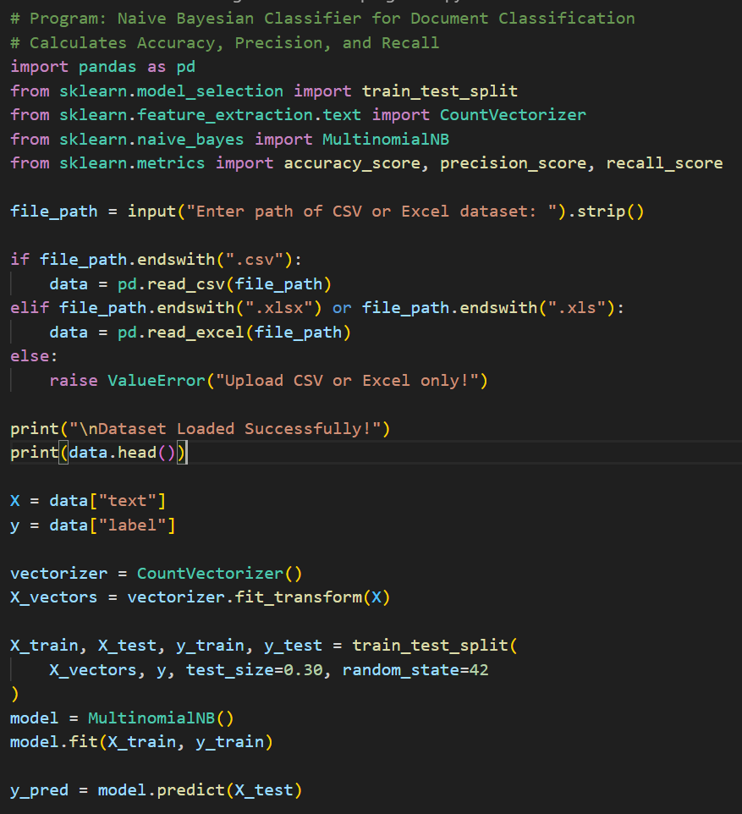
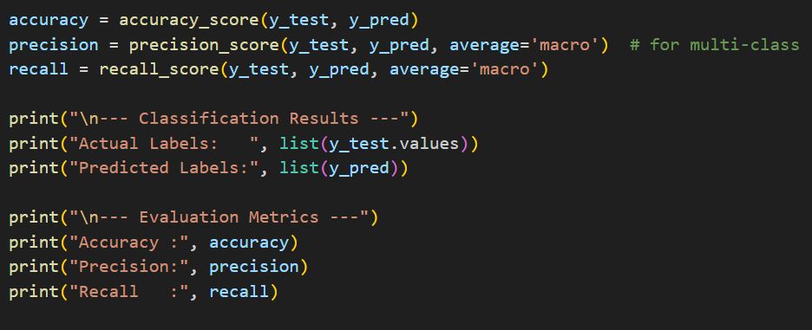
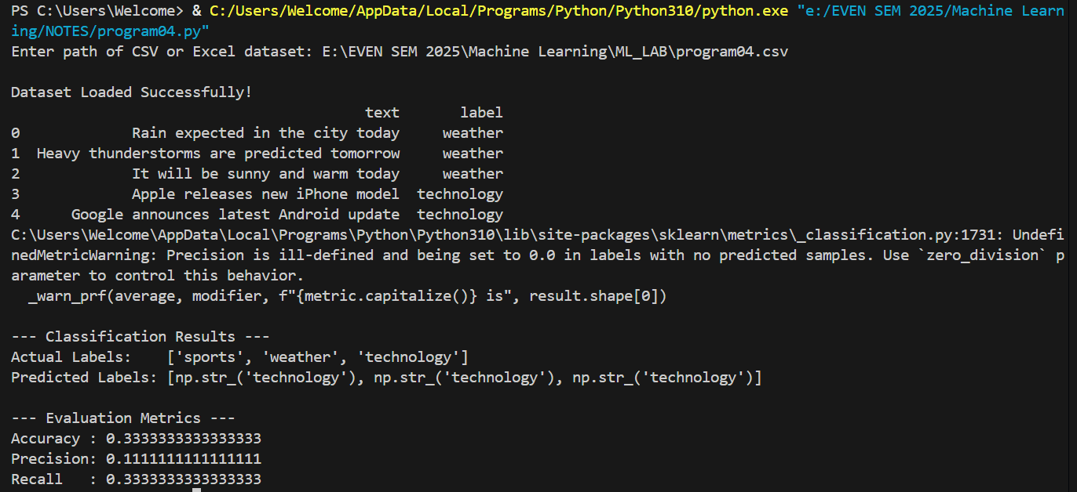

Dataset:
text | label
Rain expected in the city today | weather
Heavy thunderstorms are predicted tomorrow | weather
It will be sunny and warm today | weather
Apple releases new iPhone model | technology
Google announces latest Android update | technology
New AI tool developed for businesses | technology
The football team won the match | sports
Cricket world cup final scheduled next week | sports
The star player scored a hat trick | sports

5. Write a program to construct a Bayesian network considering medical data. Use this model to demonstrate the diagnosis of heart patients using standard Heart Disease Data Set.

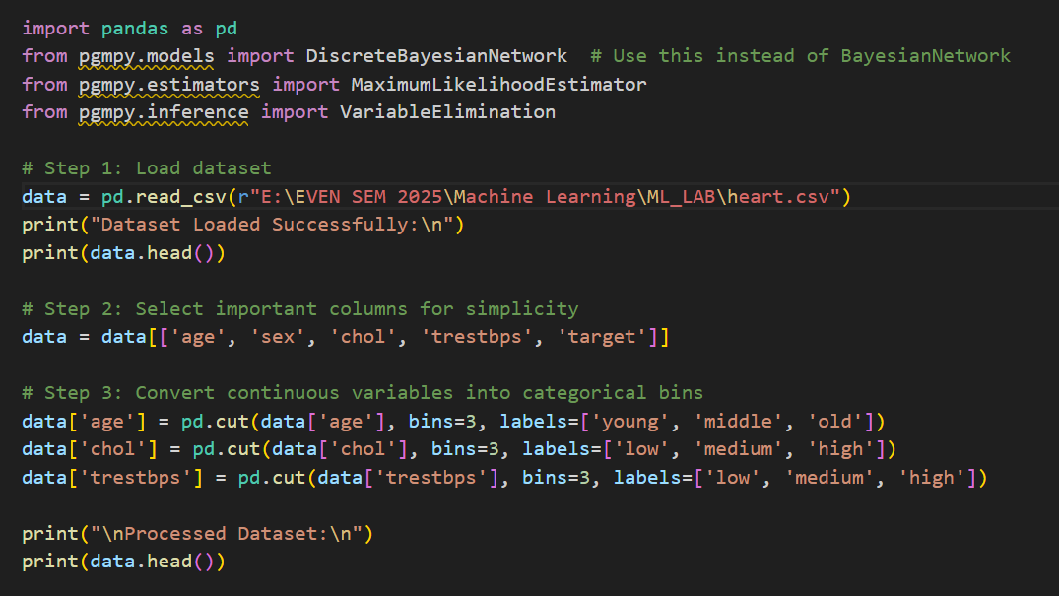
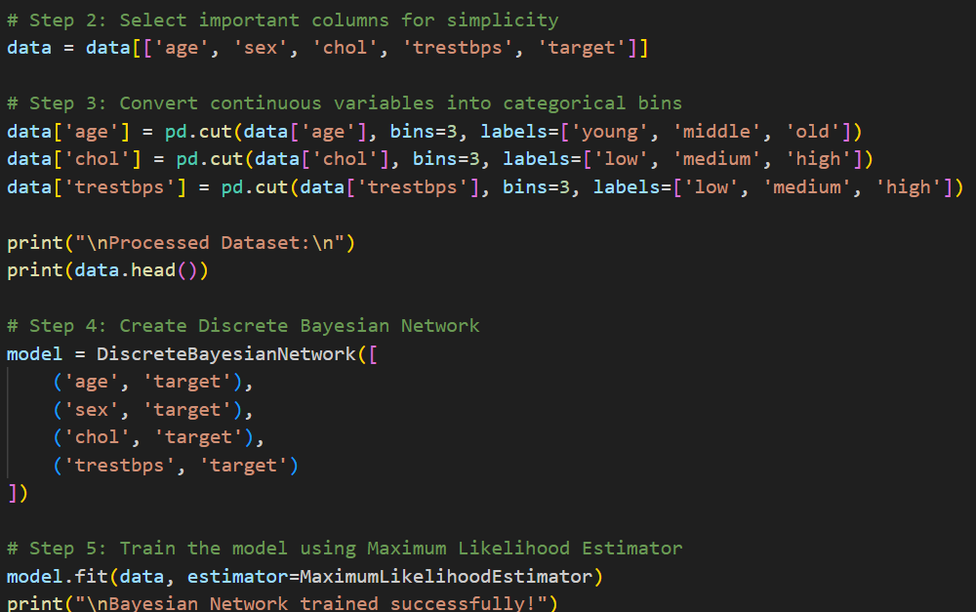
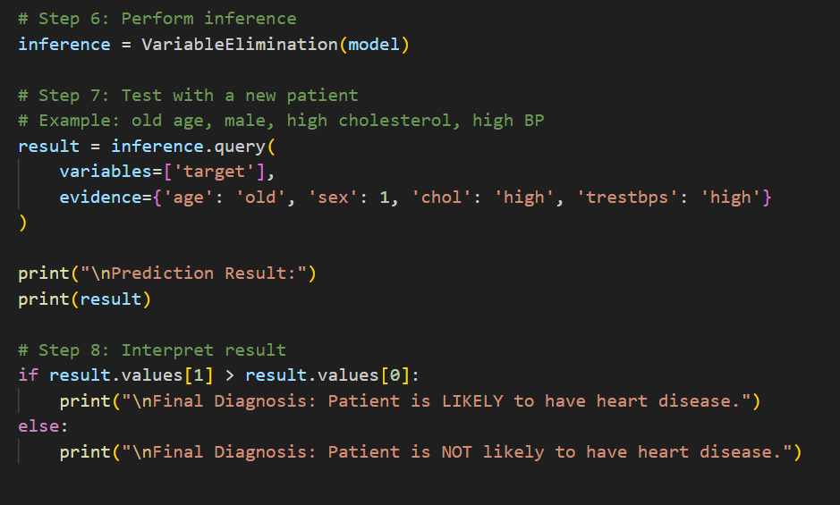
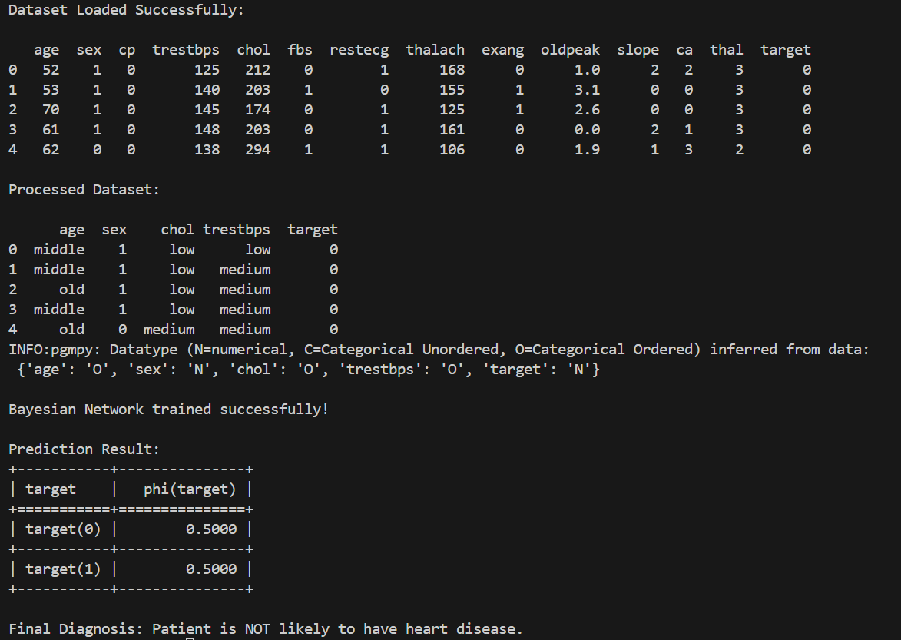

Dataset:heartdisease.csv

Program No 6: Write a program to demonstrate the working of the decision tree based ID3 algorithm. Use an appropriate data set for building the decision tree and apply this knowledge to classify a new sample.

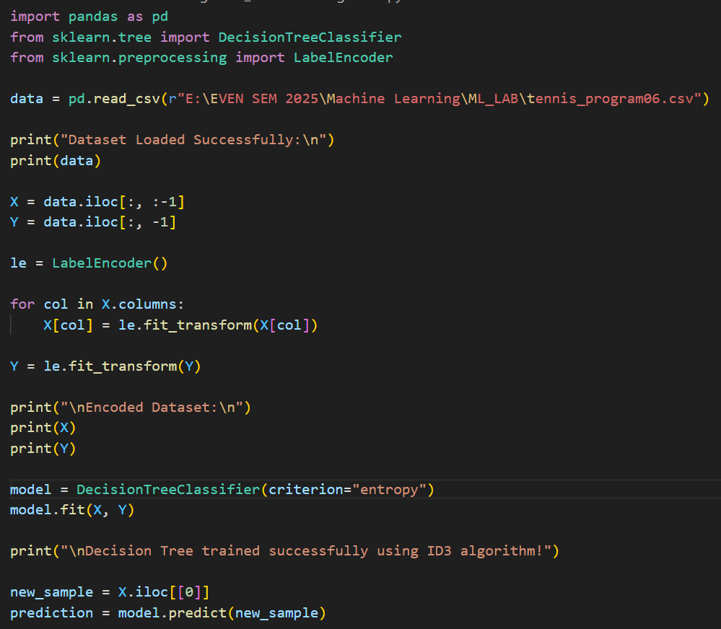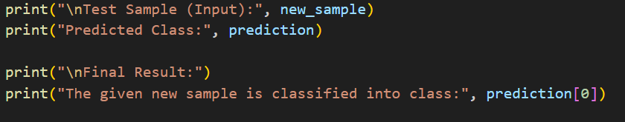

Output:
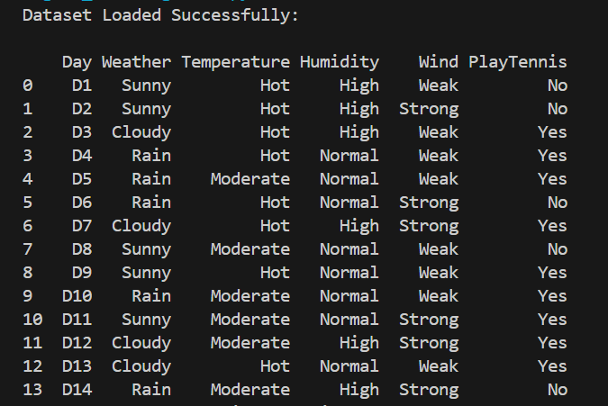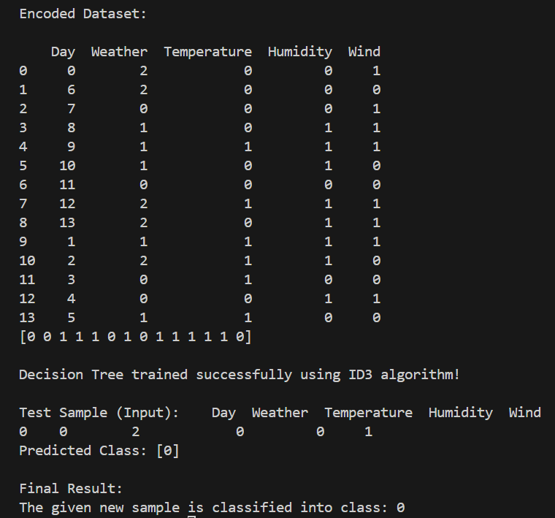
Dataset:
Day | Weather | Temperature | Humidity | Wind | PlayTennis
D1 | Sunny | Hot | High | Weak | No
D2 | Sunny | Hot | High | Strong | No
D3 | Cloudy | Hot | High | Weak | Yes
D4 | Rain | Hot | Normal | Weak | Yes
D5 | Rain | Moderate | Normal | Weak | Yes
D6 | Rain | Hot | Normal | Strong | No
D7 | Cloudy | Hot | High | Strong | Yes
D8 | Sunny | Moderate | Normal | Weak | No
D9 | Sunny | Hot | Normal | Weak | Yes
D10 | Rain | Moderate | Normal | Weak | Yes
D11 | Sunny | Moderate | Normal | Strong | Yes
D12 | Cloudy | Moderate | High | Strong | Yes
D13 | Cloudy | Hot | Normal | Weak | Yes
D14 | Rain | Moderate | High | Strong | No

